**Peshawar:**

Kanishka Stupa

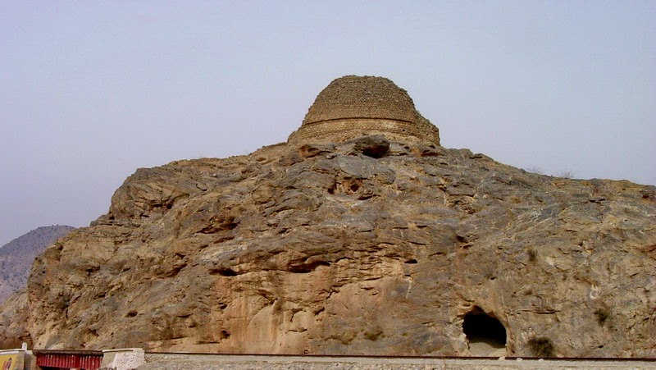

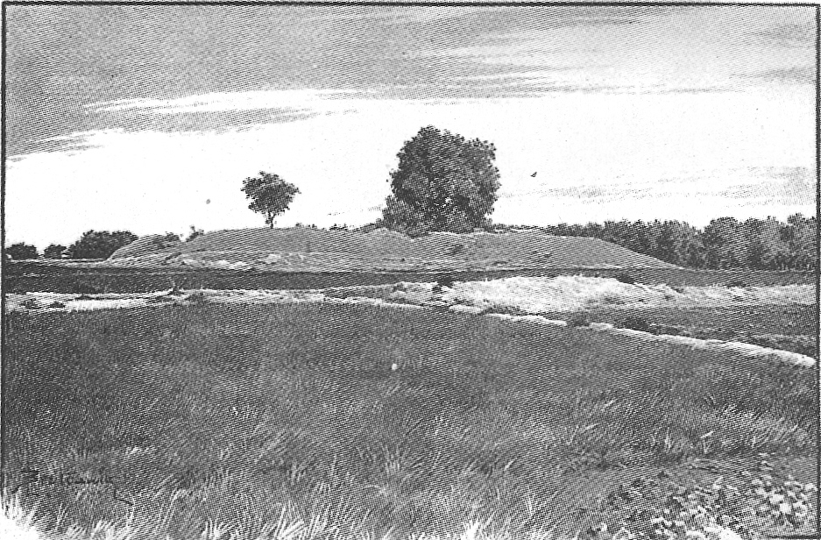

The **Kanishka stupa** was a monumental stupa established by the Kushan king Kanishka during the 2nd century CE in today's Shaji-ki-Dheri on the outskirts of Peshawar, Pakistan.The stupa was built during the Kushan era to house Buddhist relics, and would become perhaps the tallest buildings in the ancient world. The stupa is also famous for its Buddhist relics, which were transferred to the U Khanti Hall at Mandalay Hill, in Mandalay, Burma after their discovery.